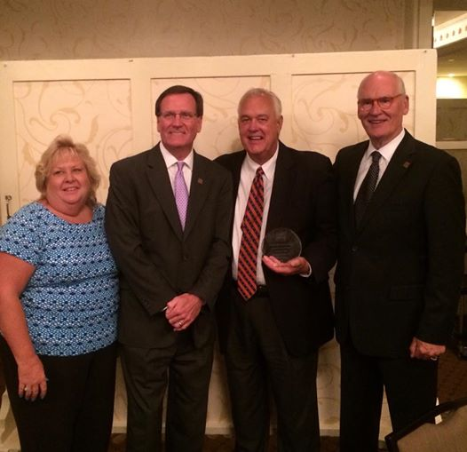
From Left: Lynne Stokley, CEO, Easter Seals Alabama, Frank Harkins, CEO Goodwill Easter Seals of the Gulf Coast, Joe Helm, Assistant Commissioner, Alabama Department of Rehabilitations Services (ADRS), Retired, Jim Williams, President and CEO, National Easter Seals.

Joe Helm, ADRS retired Assistant Commissioner and AER Treasurer was recognized by the National Easter Seals Board of Directors as 2014 National Easter Seals Outstanding State Advocate! The award was presented by Easter Seals President Jim Williams at the 2014 Advocacy Summit held June 22-24, 2014 at the Capitol Hilton Hotel, in Washington, D.C.

By Lynne Stokley, CEO, Easter Seals Alabama

Joe has long been the ultimate friend to Alabama’s Community Rehabilitation Programs – this network of 25 CRP’s provides services statewide. While Joe’s role as Assistant Commissioner of the Alabama Department of Rehabilitation Services (ADRS) demanded his attention to CRP’s, his consideration goes beyond to a true concern and commitment to the stability and growth of services.

Easter Seals Alabama has a long history of a strong partnership with our state vocational rehabilitation agency – and for about 25 years, Joe has consistently been the face and voice of our programs at that state level. Joe has been active in our Easter Seals Board meetings and committee work throughout the state when called upon and he gained the trust and respect of our Board members. His work included ensuring that our funding from the state agency was not just adequate, but that funding was done so that our consumers received quality services from trained staff in appropriate facilities and locations.

Because many of our Easter Seals facilities are co-located with ADRS, Joe has spearheaded numerous building and construction projects, renovations, and state lease agreements. He has represented our interests at legislative oversight committees and helped us navigate new state funding mechanisms as our legislative leadership has changed through the years.
Joe’s work really permeates his entire life – his life is about being a support to people who are underserved. He initiated an endowment fund that provides scholarships to students desiring to work in the field of blindness and rehabilitation. He was the author and major developer of funds that capitalized and created Southern Disability Foundation – providing low interest loans for persons with disabilities needing assistive technology such as an accessible vehicle. And he also has a group of golf friends who consistently assist local individuals – specifically working with Easter Seals Camp ASCCA. His work at ADRS also included managing the areas of Supported Employment and Alabama’s Business Enterprise Program (BEP). During his 19 years of management work with BEP the program grew from $14 million in revenue to $28 million.

Joe’s efforts and work have made such a difference in the lives of Alabamians with disabilities, their families and those of us who have worked alongside him. He retired in April after devoting 44 years to the field of rehabilitation. Upon his retirement, all the CRP’s in the state with Vocational Evaluation services proudly named their vocational evaluation units in his honor. We will miss him on a professional level – but know that he continues in personal endeavors that will support the work we continue. He has set a great example of a servant, an advocate and true mover & shaker in our field. We are proud that his career started in 1970 as a program coordinator with an Easter Seals Alabama facility in Montgomery. And so proud to recognize him as an Outstanding State Advocate tonight. Please join me in thanking Joe Helm.

